Moyagabo Raphasha
ST10471918

PROGRAMMING 2B
PART 1
PROG6212

Contents
SECTION A 2
SECTION B 8
SECTION C 13
References 27

SECTION A
ENTITY RELATIONSHIP DIAGRAM ERD
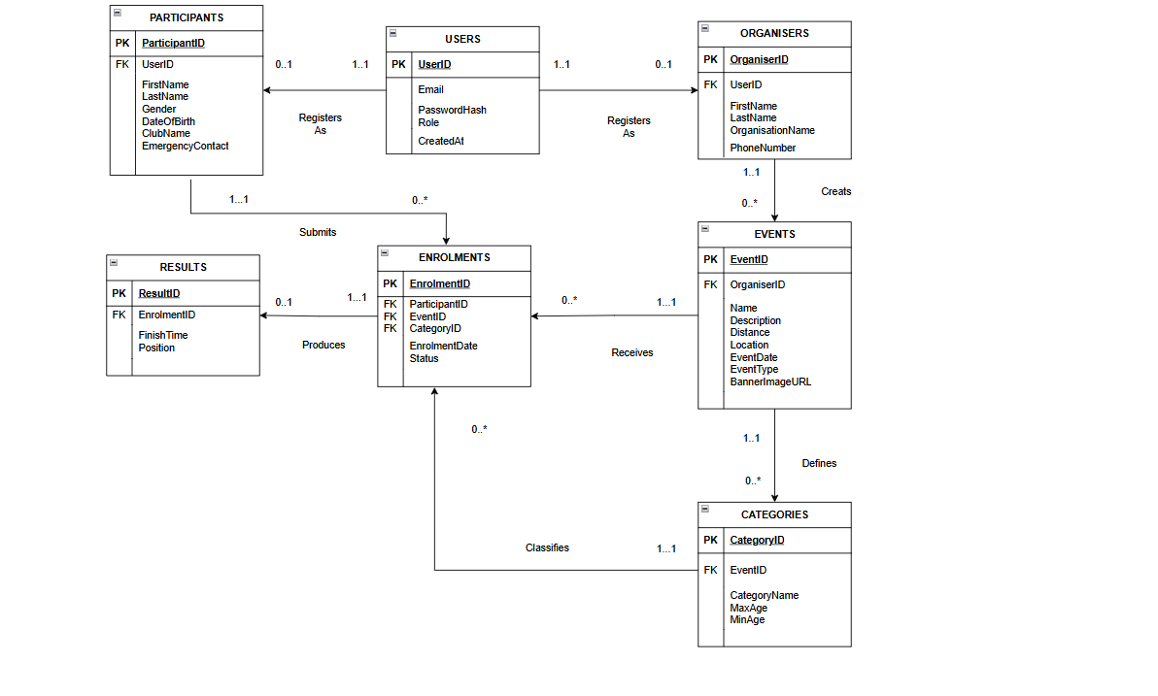
Detailed explanation of the ERD
1.The USERS table is for authentication as well as identity management.It is the foundation of the whole system.It stores information from all users.It conations the following attributes:
- UserID which is the unique identifier also known as the primary key.
- Email this is what helps the user login and it should be unique
- A PasswordHash which is a secure hashed passed that isn’t stored in plain text.
- Role which determines where the user is a participant or the organiser.
- CreatedAt timestamp of when the account was created.
2.The PARTICIPANTS TABLE stores information about the people that will be participating in the event .The information in this table is participant specific because we want to classify roles.It contains the following attributes:
- ParticipantID which is the unique identifier also known as the primary key.
- UserID which is a foreign key linking the USERS table .
- FirstName as well as LastName are personal details of the participant.
- DateOfBirth which is needed for the verification in age based categories.
- Gender which is used when theres a gender specific category.
- EmergencyContact incase of illness or injury.
- Clubname which is for optional running or cycling club.
3.The ORGANISERS Table stores the profile information about the organisers of the event.This information is organiser specific to maintain classifaction of roles.It contains the following attributes:
- OrganiserID which is the unique identifier also known as the primary key.
- UserID (FK): which is a foreign key linking the USERS table .
- FirstName as well as LastName are personal details of the participant
- OrganisationName which is the name of the event company.
- PhoneNumber: Contact number which will be used for event coordination
4.The EVENTS TABLE is responsible for storing race events.The whole system depends on this entity and note that a event is created and managed by a Organiser.It contains the following attributes:
- EventID which is the unique identifier also known as the primary key.
- OrganiserID which is a foreign key linking the ORGANISER table .to identify the organiser who created that particular event
- Name which is Event name for example Joburg Spring 20km
- Description is a detailed description of the event that is going to happen.
- EventDate is all about when the event will take place.
- Location of the event
- Distance of the race in kilometres for example15.5 for 15.5km
- EventType the type of event for example Run, Walk, or Cycle
- BannerImageUrl which is the URL for event banner image for Azure Blob Storage which will be done in Part 3
5.The CATEGORIES Table stores the age as well as the categories in each event.This is to help group participants in order to have fairness for example under 21 or Veteran which is 41.It contains the following attributes:
- CategoryID which is the unique identifier also known as the primary key.
- EventID which is a foreign key linking the EVENTS table
- CategoryName which is the name of the category for example Under 21
- MinAge and MaxAge which is a Age range for age-based categories and can be nullable for open categories.
6.The ENROLMENTS Table is the bridge table to help solve the many to many relationships between participants and events.We do this by basically introducing a one to many relationship on both sides. This table captures the complete entry ticket about who, what event and which category.It contains the following attributes:
- EnrolmentID which is the unique identifier also known as the primary key.
- ParticipantID which is a foreign key linking the PARTICIPANTS table
- EventID which is a foreign key linking the EVENTS table
- CategoryID which is a foreign key linking the CATEGORIES table
- Status which shows the Current status of the enrolment for example Pending, Confirmed, or Cancelled
- EnrolmentDate which tells the user when they enrolled into the event.
7.Lastly the RESULTS Table which stores the result of the events once completed for each participant.This table is used to show the participants their performance.It contains the following attributes:
- ResultID which is the unique identifier also known as the primary key.
- EnrolmentID which is a foreign key linking the ENROLMENTS table
- FinishTime which is the time the participant finishedfor example 01:20:30 for 1 hour 20 minutes
- Position which is the place they won or the finishing position for example 2 means 2nd place
The relationship is as follows:
1.Between USERS and PARTICIPANTS Table
- USERS
(0..1): A user may have 0 or 1 participant profile. If the user registered as an Organiser of the event, then they will have ZERO participant records. If registered as a Participant, they will have exactly ONE record.
- PARTICIPANTS
(1..1): Every single participant record must belong to exactly 1 user account . You cant have a participant profile floating around without any login details.
2.Between USERS and ORGANISERS Table
- USERS
(1..1): Every organiser must belong to exactly 1 user account
- ORGANISERS
(0..1): A user may have 0 or 1 organiser profile. If they registered as a Participant, they have 0 organiser records.

3. Between ORGANISERS and EVENTS Table
- ORGANISERS
(1..1): A event must have exactly 1 organising entity. An event cannot exist without an organiser.
- EVENTS
(0..*): An organiser can create 0 events for example just registered, hasn't created anything yet OR many events for example manages multiple races throughout the year.

4. Between EVENTS and CATEGORIES Table
- EVENTS
(1..1): Every category must belong to exactly 1 event. A category like Under 21 only makes sense within the context of a specific race.
- CATEGORIES
(0..*): An event can have zero categories if a organiser hasn't set them up yet or many categories for example Under 21, Senior and Veteran

5. Between PARTICIPANTS and ENROLMENTS Table
- PARTICIPANTS
(1..1): Every enrolment must be submitted by exactly 1 specific participant
- ENROLMENTS
(0..*): A participant can submit 0 enrolments for example if they registered but hasn't entered any races or many enrolments if the participant entered multiple races throughout the year

6. Between EVENTS and ENROLMENTS Table
- EVENTS
(1..1): Every enrolment must be for exactly 1 event
- ENROLMENTS
(0..*): An event can receive 0 enrolments for example if nobody has signed up yet or many enrolment for example 50 runners

7. Between CATEGORIES and ENROLMENTS Table
- CATEGORIES
(1..1): Every enrolment must specify exactly 1 category. A runner enters the "Senior" category, not multiple categories at once for example u cannot enter Senior and Youth..
- ENROLMENTS
(0..*): A category can have 0 enrolments for example if nobody chosen this bracket or many enrolments for example 50 runners all entered the Senior category

8.Between ENROLMENTS and RESULTS Tables
- ENROLMENTS
(1..1): Each result must belong to exactly 1 enrolment. A finish time only makes sense in the context of a specific person entering a specific race .
- RESULTS
(0..1):
  - 0 : The enrolment has 0 results because the race hasn't happened yet, or the participant registered but didn't show up
  - 1 : The race is over and the organiser has captured the participant's finish time and position
  - NEVER more than 1: A participant can only have 1 result per race entry

SECTION B
API Endpoint Plan
HTTP Method | Route | Description) | Role Required | Request Body (JSON) | Expected Response
Post | /api/auth/register | Registers a new user, hashes the password, and creates either an Organiser or Participant profile based on the selected role. | None(Public) | { "email", "password", "role": "Organiser/Participant", "firstName": ,"lastName"} | 201 Created: User profile created.  400 Bad Request: Invalid input/missing fields.  409 Conflict: Email already exists.
Post | /api/auth/login | Authenticates user credentials, creates a server-side session, and stores UserID and Role. | None(Public) | { "email": "string", "password": "string" } | 200 OK: Login successful, session created.  401 Unauthorized: Invalid email or password.
Post | /api/auth/logout | Clears the user's session and logs them out of the system. | Any(Logged In) | None | 200 OK: Logged out successfully.
Get | /api/profile | Retrieves the logged-in user's specific profile details (Organiser or Participant). | Any | none | 200 OK: Returns profile JSON.  401 Unauthorized: Not logged in.  404 Not Found: Profile not found.
Put | /api/profile | Updates the logged-in user's profile details (e.g., phone number, club name, emergency contact). | Any | { "firstName": "string", "lastName": "string", "phone": "string" } | 200 OK: Profile updated.  400 Bad Request: Invalid data.
Get | /api/events | Retrieves a list of all upcoming events. | Any | None | 200 OK: Returns list of events.
Get | /api/events/{id} | Retrieves full details for a specific event, including its categories. | Any | none | 200 OK: Returns event details.  404 Not Found: Event does not exist.
Post | /api/events | Creates a new event. Automatically links to the logged-in Organiser's ID. | Organiser | { "name": "string", "description": "string", "eventDate": "datetime", "location": "string", "distance": 10.5, "eventType": "Run/Walk/Cycle" } | 201 Created: Event created.  403 Forbidden: User is not an Organiser.
Put | /api/events/{id} | Updates an existing event. Ensures the logged-in Organiser owns the event. | Organiser | { "name": "string", "description": "string" } | 200 OK: Event updated.  403 Forbidden: Not the event owner.  404 Not Found: Event not found.
Delete | /api/events/{id} | Deletes an event and its associated categories/enrolments. | Organiser | None | 200 OK: Event deleted.  403 Forbidden: Not the event owner.
Get | /api/events/{eventId}/categories | Gets all categories (e.g., Under 21, 20km) for a specific event. | Any | none | 200 OK: Returns list of categories.  404 Not Found: Event not found.
Post | /api/events/{eventId}/categories | Adds a new age/distance category to an event. | Organiser | { "categoryName": "string", "minAge": 18, "maxAge": 35 } | 201 Created: Category added.  403 Forbidden: Not an Organiser.
Post | /api/events/{eventId}/enrol | Enrols the logged-in Participant into an event under a specific category. Sets status to 'Pending'. | Participant | { "categoryId": 1 } | 201 Created: Enrolment successful.  403 Forbidden: User is not a Participant.  409 Conflict: Already enrolled in this event.
Get | /api/events/{eventId}/enrolments | Retrieves all enrolments for a specific event (for the Organiser to view/manage). | Organiser | None | 200 OK: Returns list of enrolments.  403 Forbidden: Not the event owner.
Get | /api/participant/enrolments | Retrieves all events the logged-in Participant has enrolled in ("My Events") | Participant | none | 200 OK: Returns list of my enrolments.
Post | /api/enrolments/{enrolmentId}/results | Organiser captures the finish time and position for a participant after the event. | Organiser | { "finishTime": "01:45:30", "position": 47 } | 200 OK: Results captured.  403 Forbidden: Not an Organiser.
Get | /api/participant/results | Retrieves the logged-in Participant's personal race history with times and positions. | Participant | none | 200 OK: Returns race history.

SECTION C

SQL CODE
--Creating The Database
CREATE DATABASE RaceDay;
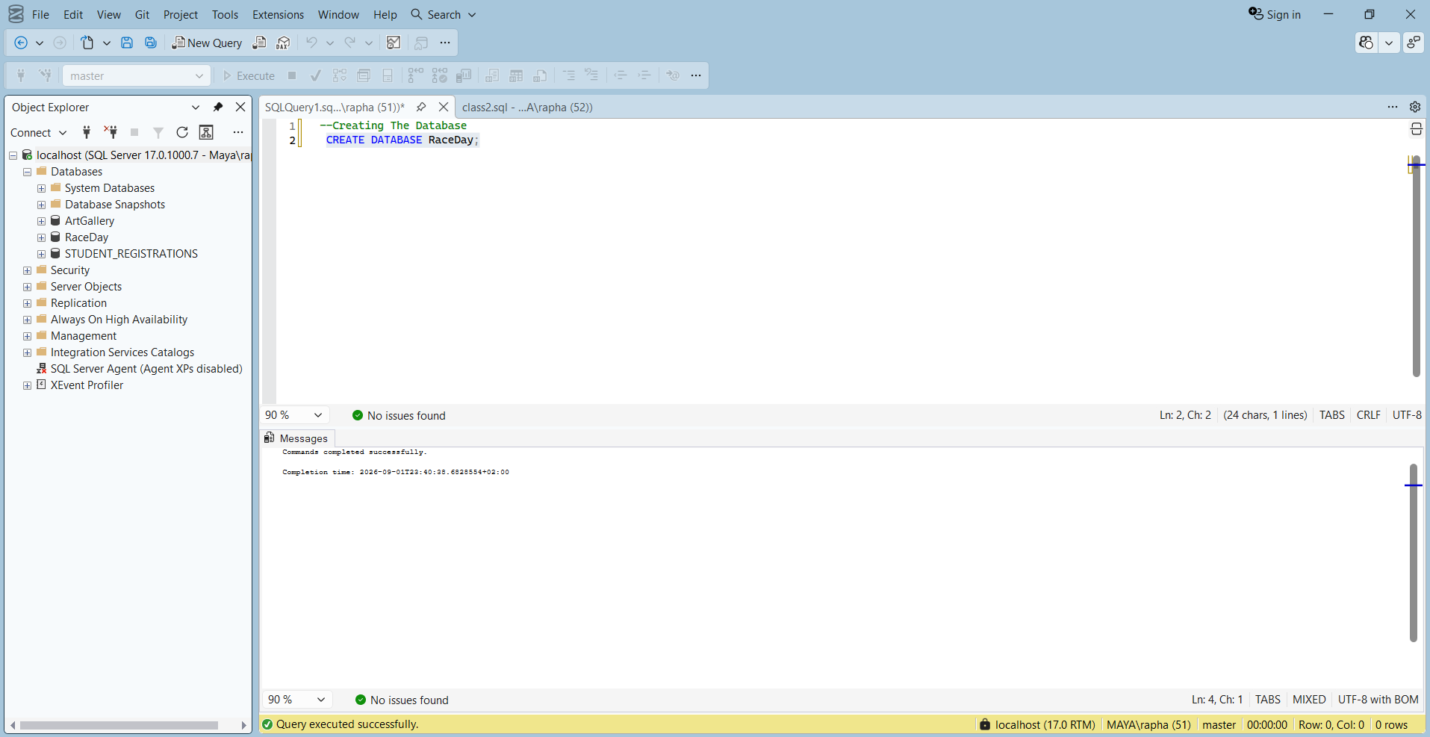

--Creating Users Table

CREATE TABLE Users (
UserID INT IDENTITY(1,1) PRIMARY KEY,
Email VARCHAR(255) NOT NULL UNIQUE,
PasswordHash VARCHAR(255) NOT NULL,
Role VARCHAR(50) NOT NULL CHECK (Role IN ('Organiser', 'Participant')),
CreatedAt DATETIME DEFAULT GETDATE()
);
Select * FROM Users;
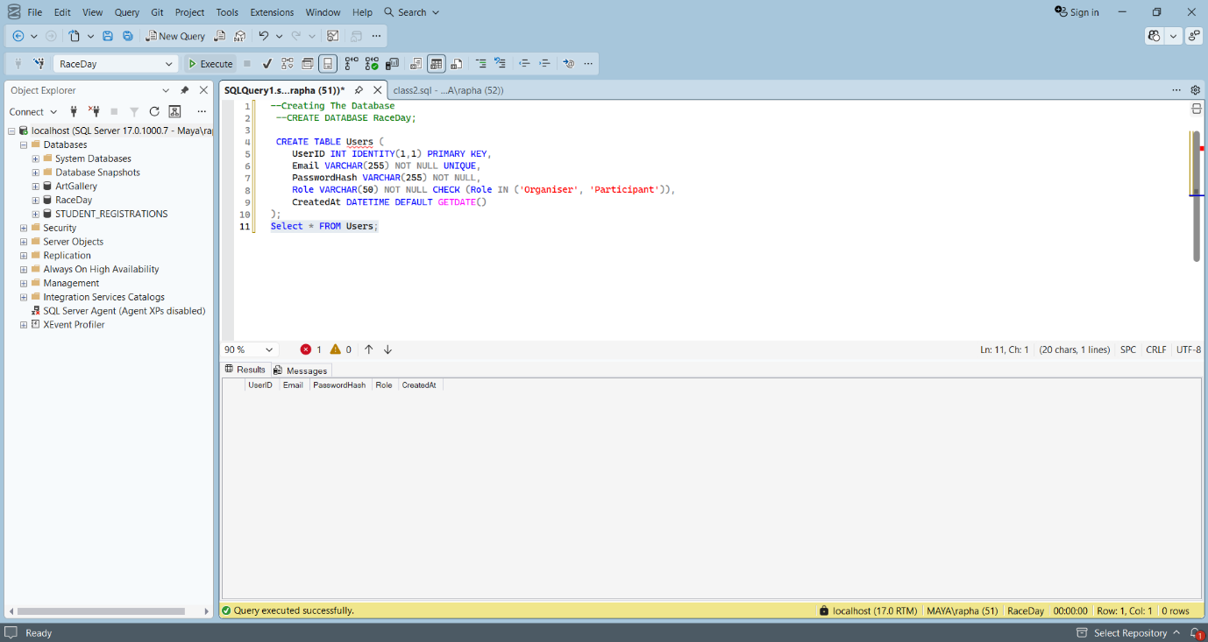

--Creating Organisers Table
CREATE TABLE Organisers (
OrganiserID INT IDENTITY(1,1) PRIMARY KEY,
UserID INT NOT NULL UNIQUE, -- UNIQUE enforces 1-to-1 relationship with Users
FirstName VARCHAR(150) NOT NULL,
LastName VARCHAR(150) NOT NULL,
OrganisationName VARCHAR(150) NULL,
PhoneNumber VARCHAR(11) NOT NULL,
CONSTRAINT FK_Organisers_Users FOREIGN KEY (UserID) REFERENCES Users(UserID)
);
SELECT * FROM Organisers
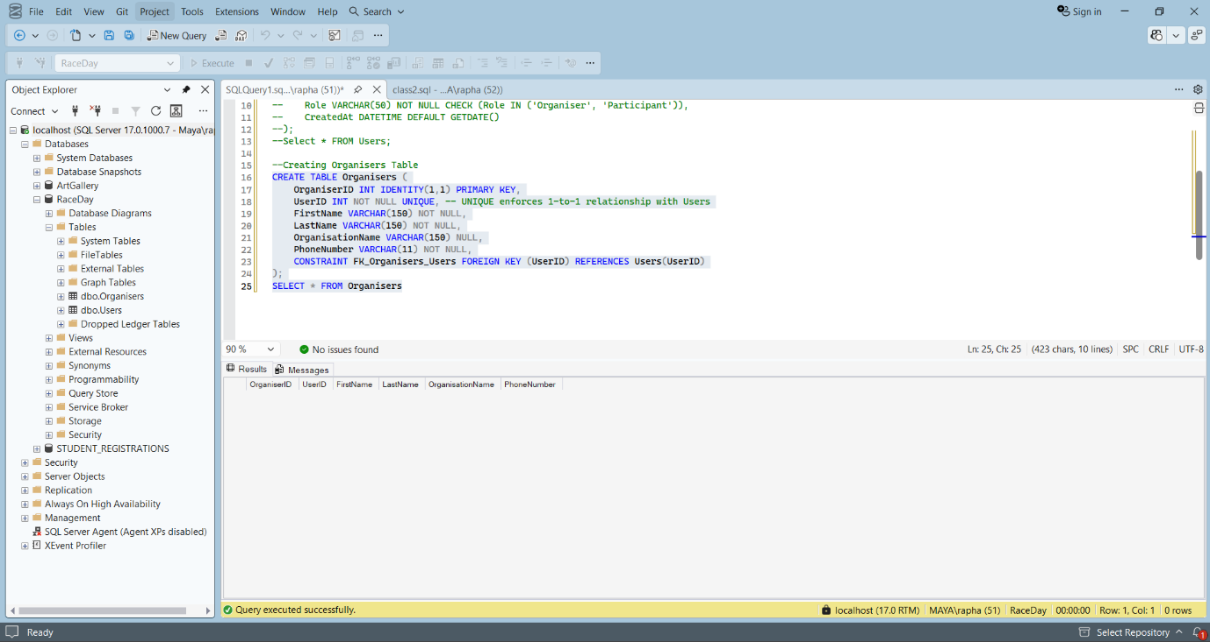

--Creating Participants Table
CREATE TABLE Participants (
ParticipantID INT IDENTITY(1,1) PRIMARY KEY,
UserID INT NOT NULL UNIQUE, -- UNIQUE enforces 1-to-1 relationship with Users
FirstName VARCHAR(150) NOT NULL,
LastName VARCHAR(150) NOT NULL,
DateOfBirth DATE NOT NULL,
Gender VARCHAR(10) NOT NULL,
EmergencyContact VARCHAR(200) NOT NULL,
ClubName VARCHAR(200) NULL,
CONSTRAINT FK_Participants_Users FOREIGN KEY (UserID) REFERENCES Users(UserID)
);
--SELECT * FROM Participants;
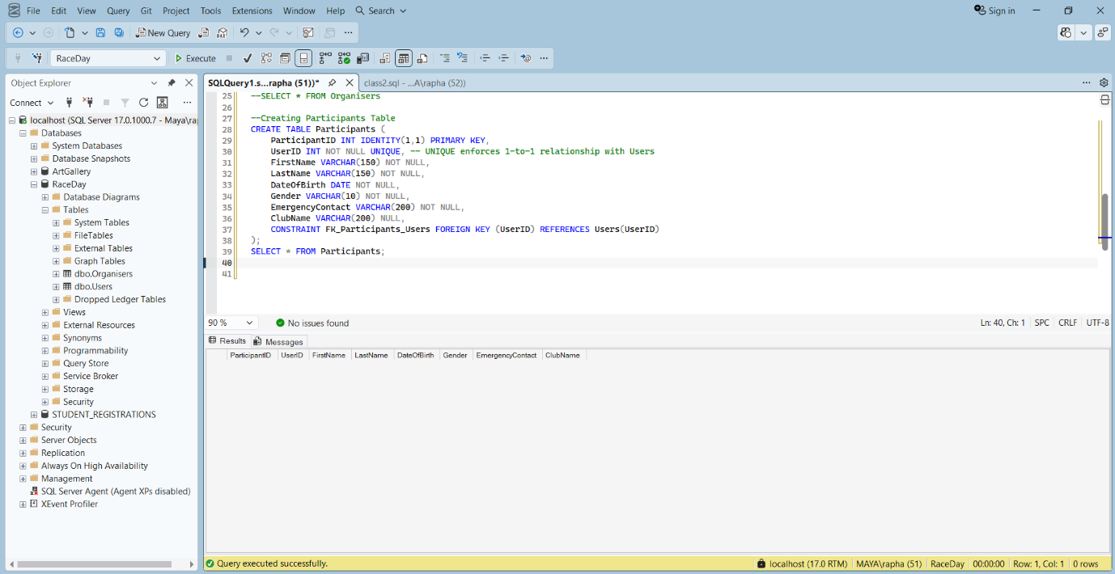

--Creating Events Table
CREATE TABLE Events (
EventID INT IDENTITY(1,1) PRIMARY KEY,
OrganiserID INT NOT NULL,
Name VARCHAR(200) NOT NULL,
Description TEXT NOT NULL,
EventDate DATETIME NOT NULL,
Location VARCHAR(200) NOT NULL,
Distance DECIMAL(5,2) NOT NULL, -- For example 10.50 for 10.5km
EventType VARCHAR(150) NOT NULL CHECK (EventType IN ('Run', 'Walk', 'Cycle')),
BannerImageUrl VARCHAR(500) NULL,
CONSTRAINT FK_Events_Organisers FOREIGN KEY (OrganiserID) REFERENCES Organisers(OrganiserID)
);
SELECT * FROM Events;
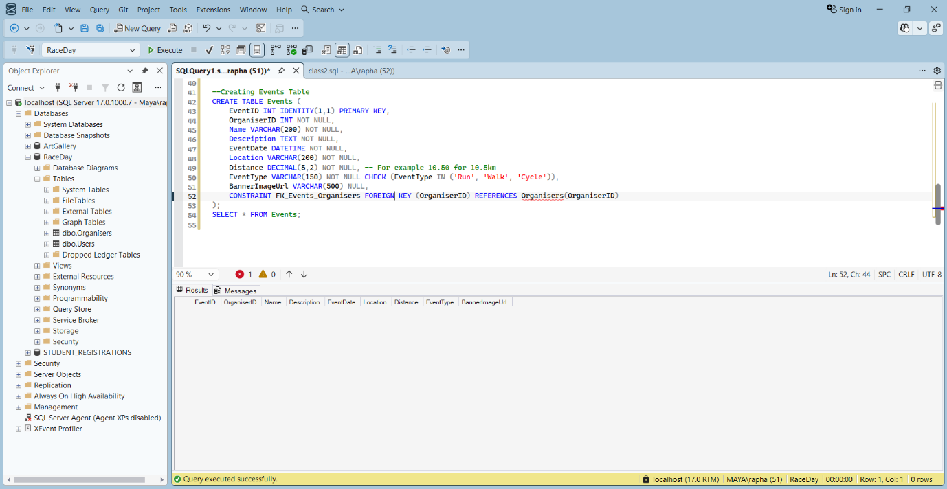

--Creating Categories Table
CREATE TABLE Categories (
CategoryID INT IDENTITY(1,1) PRIMARY KEY,
EventID INT NOT NULL,
CategoryName VARCHAR(150) NOT NULL,
MinAge INT NULL,
MaxAge INT NULL,
CONSTRAINT FK_Categories_Events FOREIGN KEY (EventID) REFERENCES Events(EventID)
);
SELECT * FROM Categories;
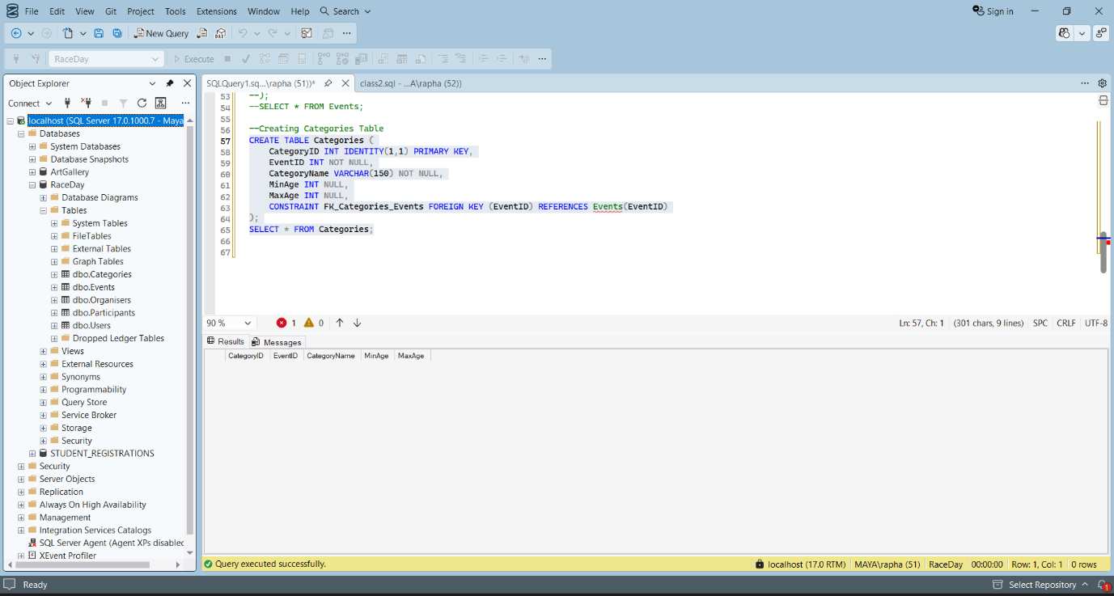

--Creating Enrolments Table
CREATE TABLE Enrolments (
EnrolmentID INT IDENTITY(1,1) PRIMARY KEY,
ParticipantID INT NOT NULL,
EventID INT NOT NULL,
CategoryID INT NOT NULL,
Status VARCHAR(50) NOT NULL DEFAULT 'Pending' CHECK (Status IN ('Pending', 'Confirmed', 'Cancelled')),
EnrolmentDate DATETIME DEFAULT GETDATE(),
CONSTRAINT FK_Enrolments_Participants FOREIGN KEY (ParticipantID) REFERENCES Participants(ParticipantID),
CONSTRAINT FK_Enrolments_Events FOREIGN KEY (EventID) REFERENCES Events(EventID),
CONSTRAINT FK_Enrolments_Categories FOREIGN KEY (CategoryID) REFERENCES Categories(CategoryID)
);
Select * FROM Enrolments;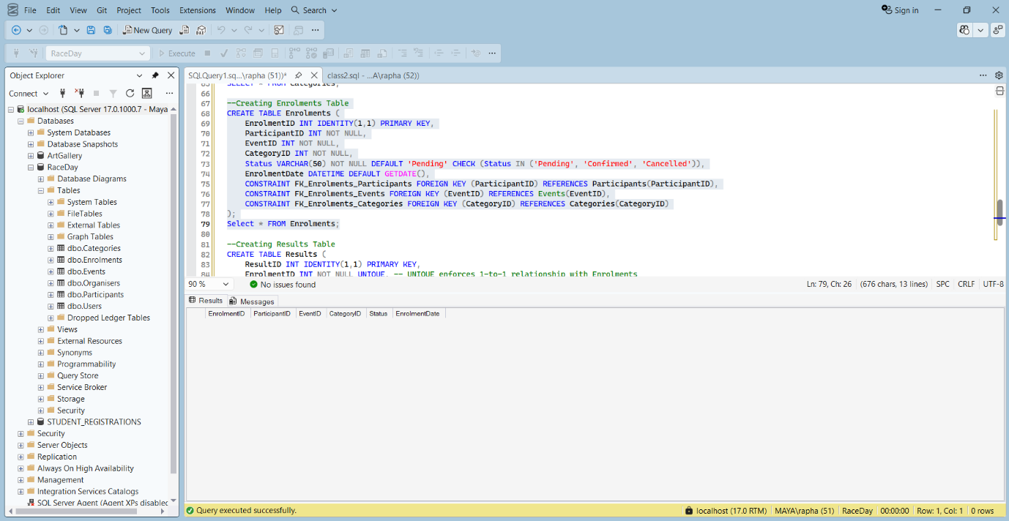

--Creating Results Table
CREATE TABLE Results (
ResultID INT IDENTITY(1,1) PRIMARY KEY,
EnrolmentID INT NOT NULL UNIQUE, -- UNIQUE enforces 1-to-1 relationship with Enrolments
FinishTime TIME NULL,
Position INT NULL,
CONSTRAINT FK_Results_Enrolments FOREIGN KEY (EnrolmentID) REFERENCES Enrolments(EnrolmentID)
);
SELECT * FROM Results;
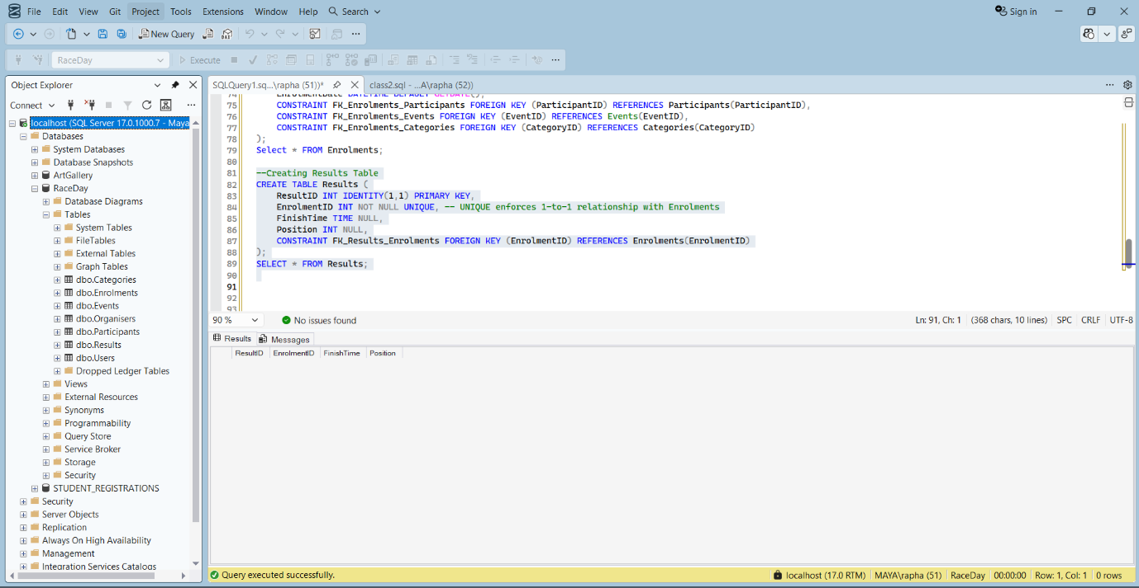

--Inserting into Users Table
INSERT INTO Users (Email, PasswordHash, Role) VALUES
('org.maya.raphasha@raceday.co.za', '$2a$11$dummyhashformaya123456789012345678901234567890', 'Organiser'),
('org.jeff.sehlwane@raceday.co.za', '$2a$11$dummyhashforjeff12345678901234567890123456789', 'Organiser'),
('part.kea.runner@raceday.co.za', '$2a$11$dummyhashforkea123456789012345678901234567890', 'Participant'),
('part.nomsa.walker@raceday.co.za', '$2a$11$dummyhashfornomsa12345678901234567890123456789', 'Participant');

SELECT * FROM Users;
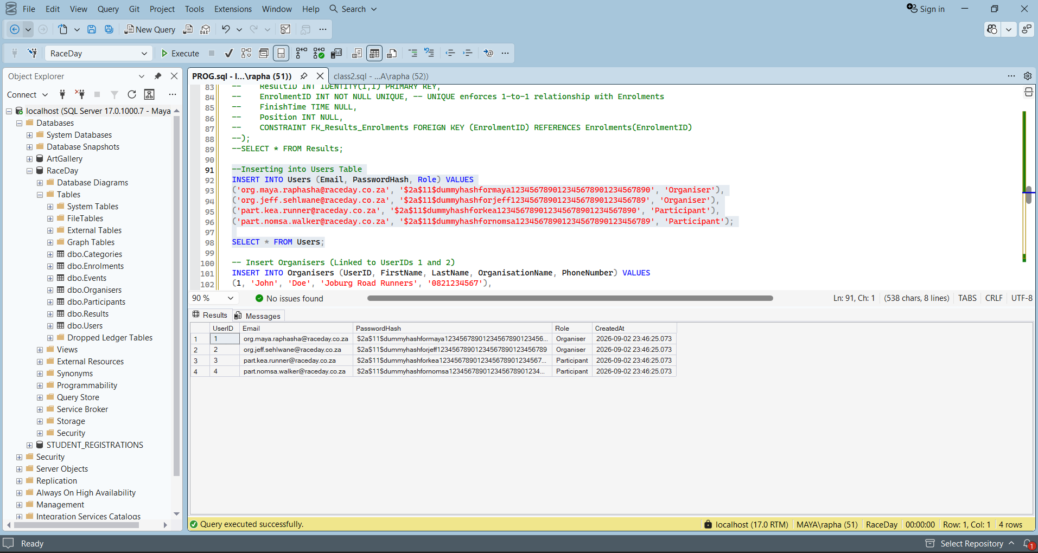

-- Inserting into Organisers Table
INSERT INTO Organisers (UserID, FirstName, LastName, OrganisationName, PhoneNumber) VALUES
(1, 'Maya', 'Raphasha', 'Joburg Road Runners', '0612127353'),
(2, 'Jeff', 'Sehlwane', 'Cape Town Cycle Club', '0720168646');

SELECT * FROM Organisers;
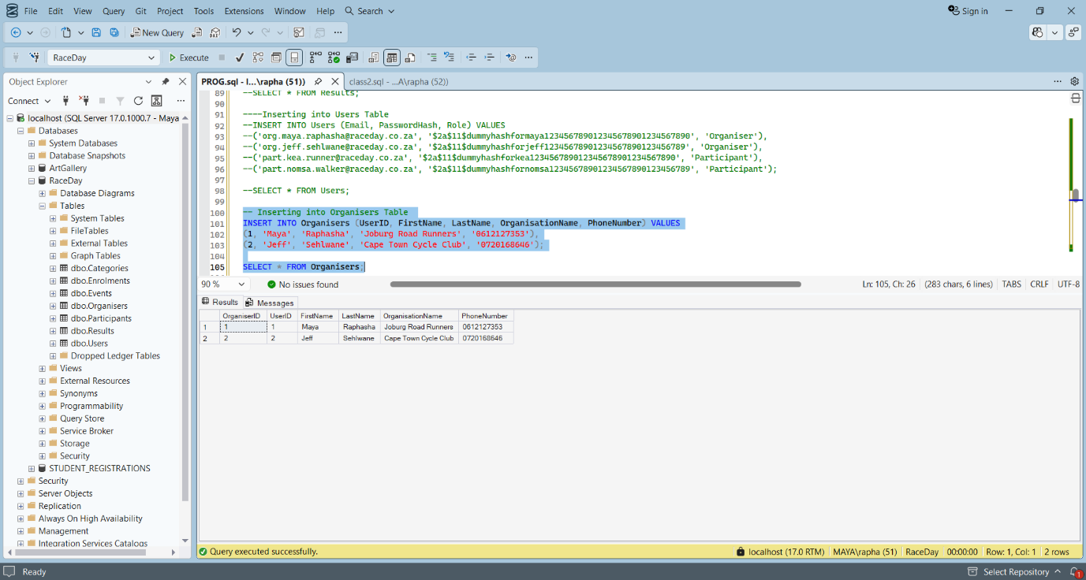

-- Inserting into Participants Table
INSERT INTO Participants (UserID, FirstName, LastName, DateOfBirth, Gender, EmergencyContact, ClubName) VALUES
(3, 'Kea', 'Runner', '2005-03-15', 'Female', '0845647543', 'Nedbank Running Club'),
(4, 'Nomsa', 'Walker', '1980-10-21', 'Female', '0873452332', NULL);

SELECT * FROM Participants;
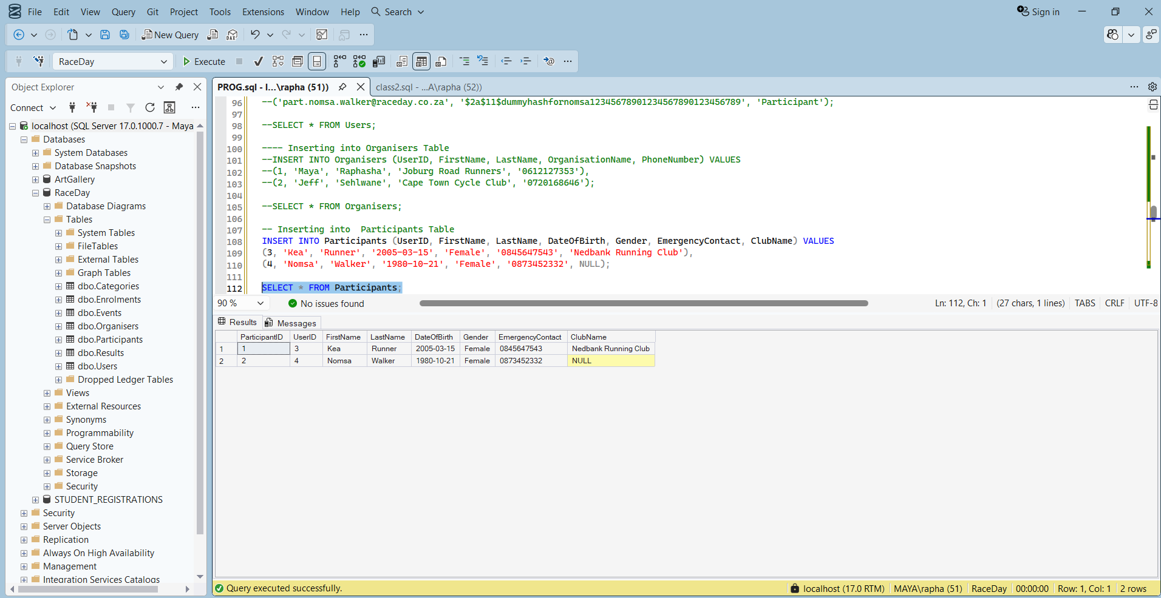

-- Inserting into Events Table
INSERT INTO Events (OrganiserID, Name, Description, EventDate, Location, Distance, EventType) VALUES
(1, 'Joburg Spring 10km', 'A scenic 10km run through the Johannesburg Botanical Gardens.', '2026-11-11 09:30:00', 'Johannesburg Botanical Gardens', 20.00, 'Run'),
(1, 'Montana Charity Walk', 'A 5km community walk to raise funds for local schools.', '2026-11-02 07:45:00', 'Doornpoort, Montana', 15.00, 'Walk'),
(2, 'Cape Point Cycle Tour', 'A challenging 50km cycle route along the beautiful coastline.', '2026-12-01 06:15:00', 'Cape Point, Cape Town', 30.00, 'Cycle');

SELECT * FROM Events;
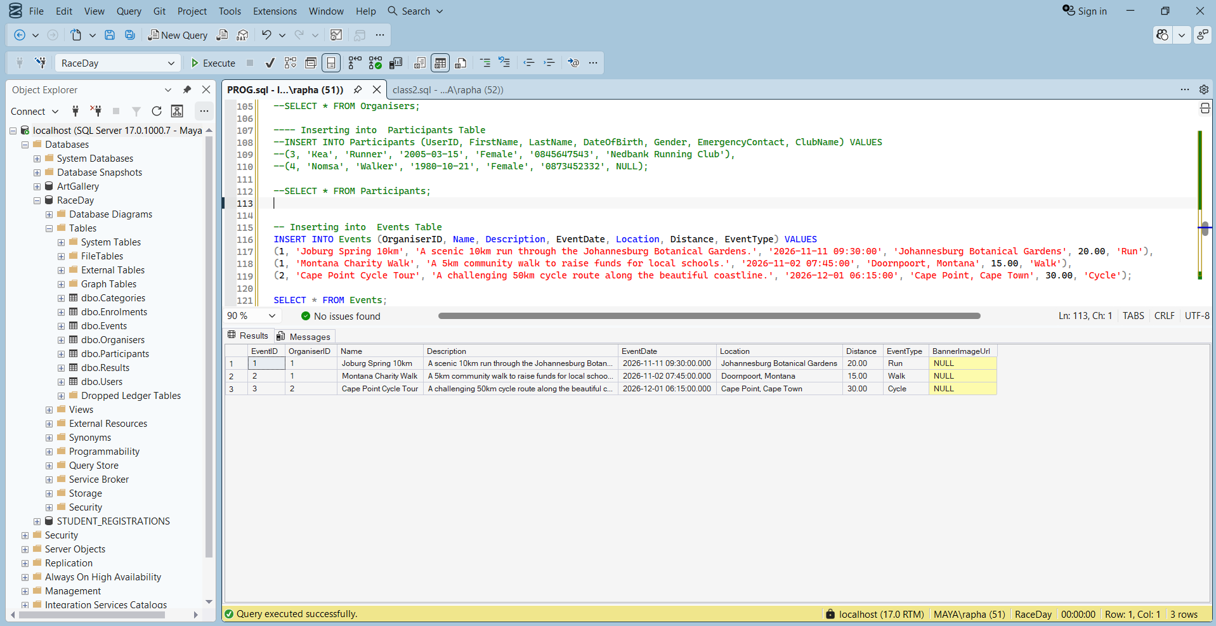

-- Inserting into Categories for the Events
-- Event 1 (Joburg 10km) Categories
INSERT INTO Categories (EventID, CategoryName, MinAge, MaxAge) VALUES
(1, 'Under 21', 10, 21),
(1, 'Senior (22-40)', 22, 40),
(1, 'Veteran (41+)', 41, 100);
SELECT * FROM Categories;

-- Event 2 (Montana Walk) Categories
INSERT INTO Categories (EventID, CategoryName, MinAge, MaxAge) VALUES
(2, 'Open', 18, 100),
(2, 'Youth', 12, 25);

SELECT * FROM Categories;

-- Event 3 (Cape Cycle Tour) Categories
INSERT INTO Categories (EventID, CategoryName, MinAge, MaxAge) VALUES
(3, '30km Elite', 18, 50),
(3, '30km Amateur', 18, 100);

SELECT * FROM Categories;
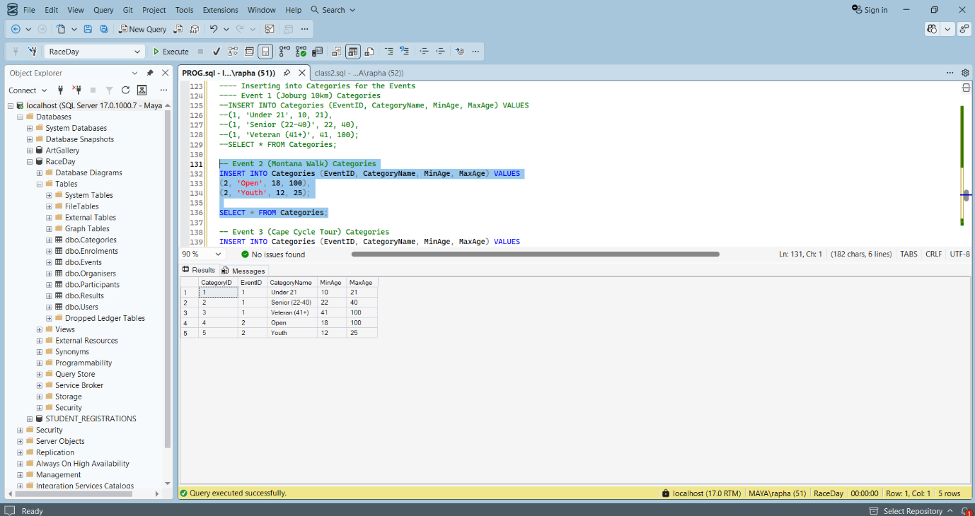
-- Insert Enrolments
-- Kea (Participant 1) enrolls in Joburg 20km (Event 1, Category 2: Senior)
INSERT INTO Enrolments (ParticipantID, EventID, CategoryID, Status) VALUES
(1, 1, 2, 'Confirmed');

-- Nomsa (Participant 2) enrolls in Montana Walk (Event 2, Category 1: Open)
INSERT INTO Enrolments (ParticipantID, EventID, CategoryID, Status) VALUES
(2, 2, 1, 'Pending');

-- Kea (Participant 1) enrolls in Cape Cycle Tour (Event 3, Category 2: Amateur)
INSERT INTO Enrolments (ParticipantID, EventID, CategoryID, Status) VALUES
(1, 3, 2, 'Pending');

SELECT * FROM Enrolments;
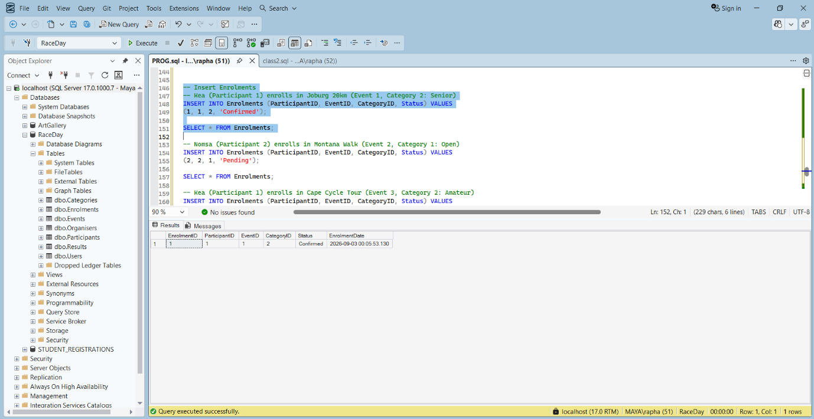

-- Insert Results (For completed events)
-- Kea finished the Joburg 20km in 30 mins, 30 secs (5th position)
INSERT INTO Results (EnrolmentID, FinishTime, Position) VALUES
(1, '00:30:30', 12);

-- Nomsa finished the Monata Walk in 50 mins, 15 secs (100th position)
INSERT INTO Results (EnrolmentID, FinishTime, Position) VALUES
(2, '00:50:15', 100);
SELECT * FROM Results;
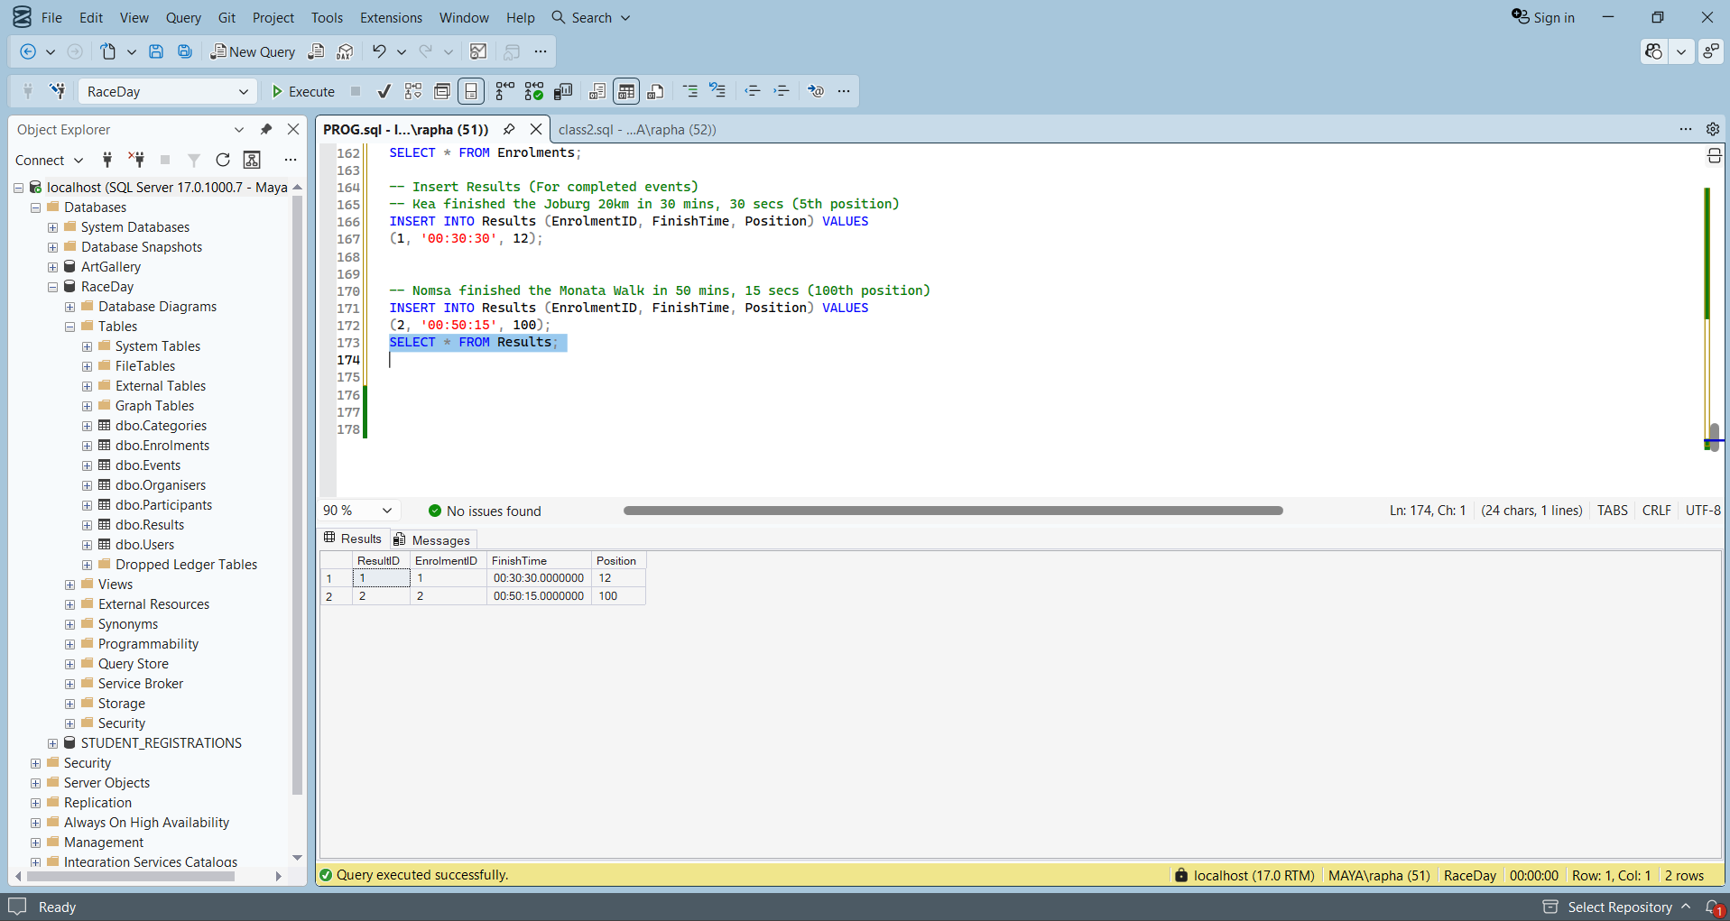

References
Coronel, C., Morris, S., Crockett, K. and Blewett, C. Database Principles: Fundamentals of Design, Implementation and Management. United Kingdom: Cengage Learning EMEA., 2020. Textbook.
Data, Refsnes. W3Schools. 1999-2026. Web page. 01 09 2026.

